Stepping into GDB

Launch GDB on Your ELF File

Command- riscv32-unknown-elf-gdb hello.elf

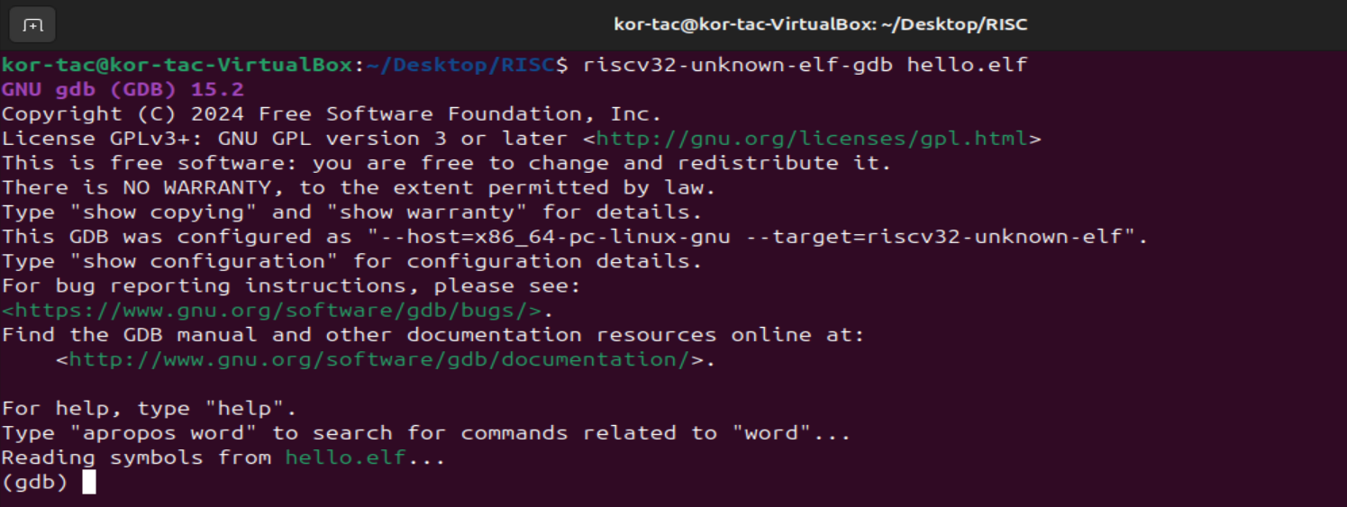

Once inside this type “ (gdb) break main” this will set the breakpoint at the main function

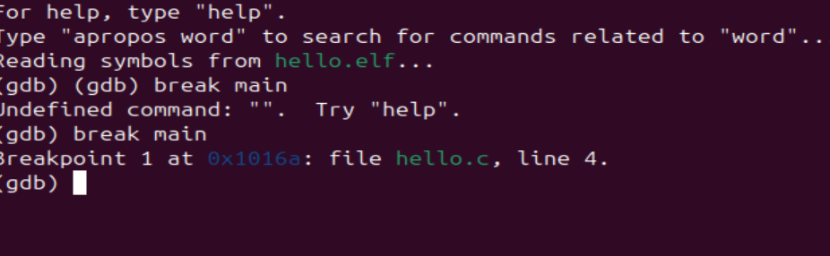

Now to start/run the program enter “(gdb) run

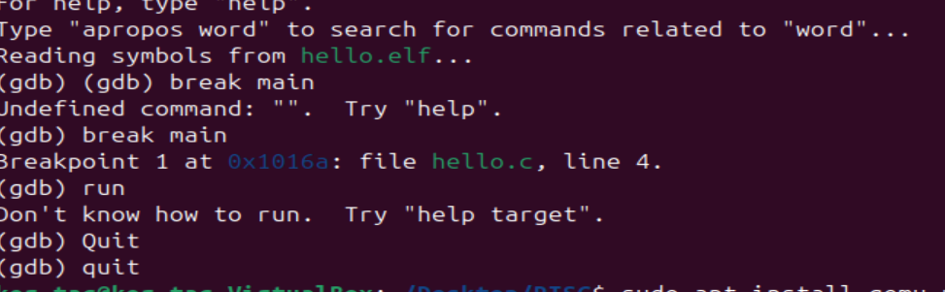

We need QEMU to run it

To install

sudo apt install qemu-user qemu-user-static

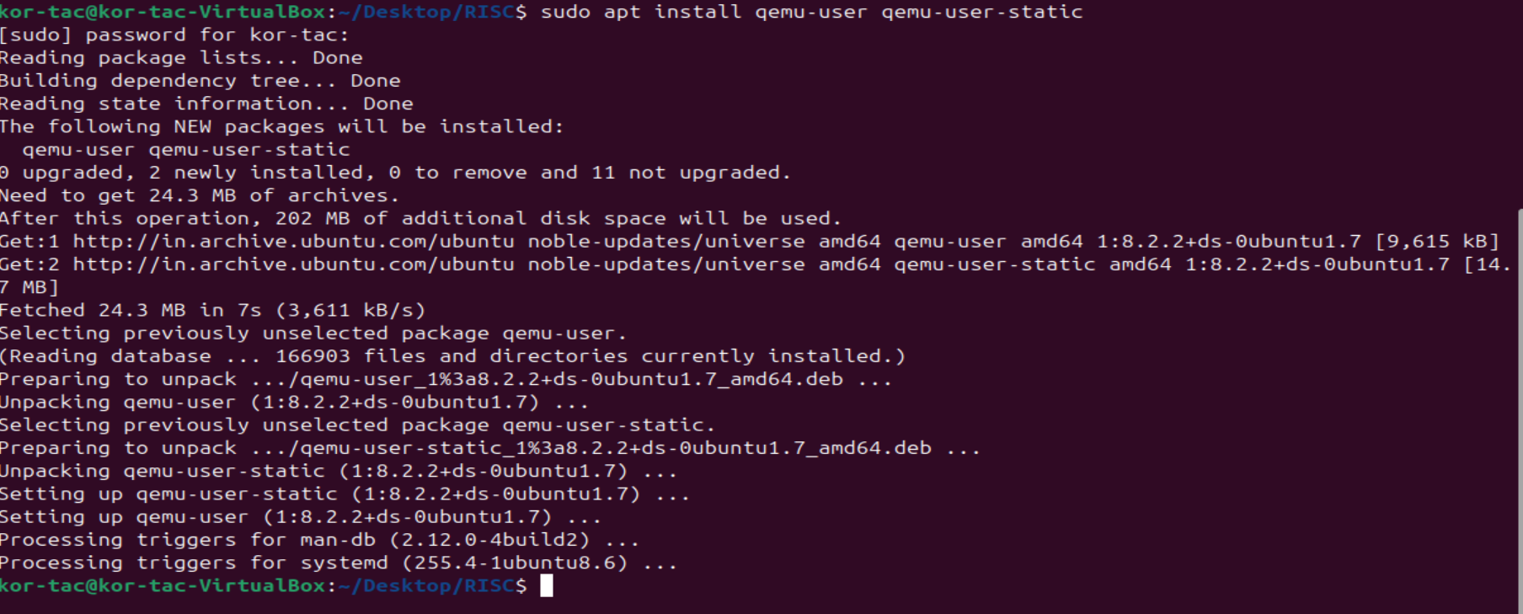

QEMU is installed

Now in new terminal run this command

qemu-riscv32 -g 1234 hello.elf

Port used is 1234

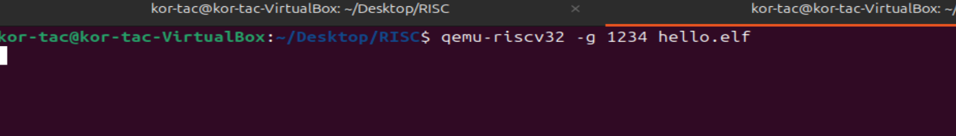

Now inside GDB type (gdb) target remote localhost:1234

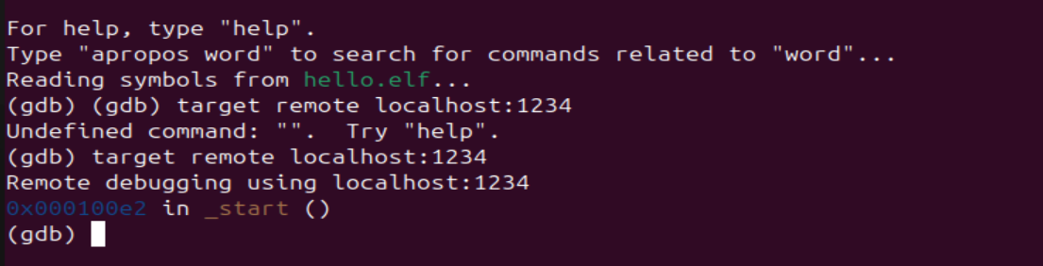

Now type in GDB

break main

continue

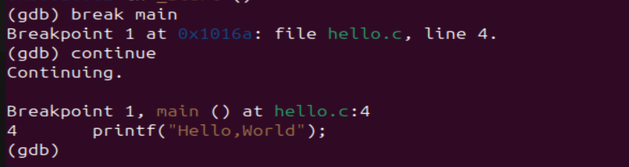

Debug interactively

(GDB) stepi

(GDB) info registers

